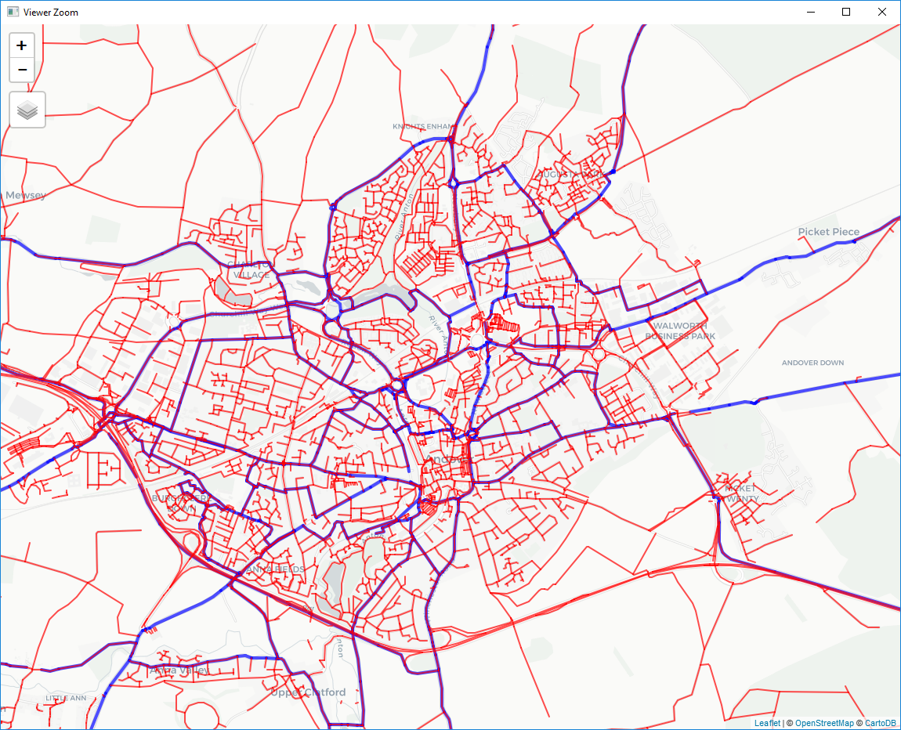

Andover All OSM Red, only intersecting routes blue

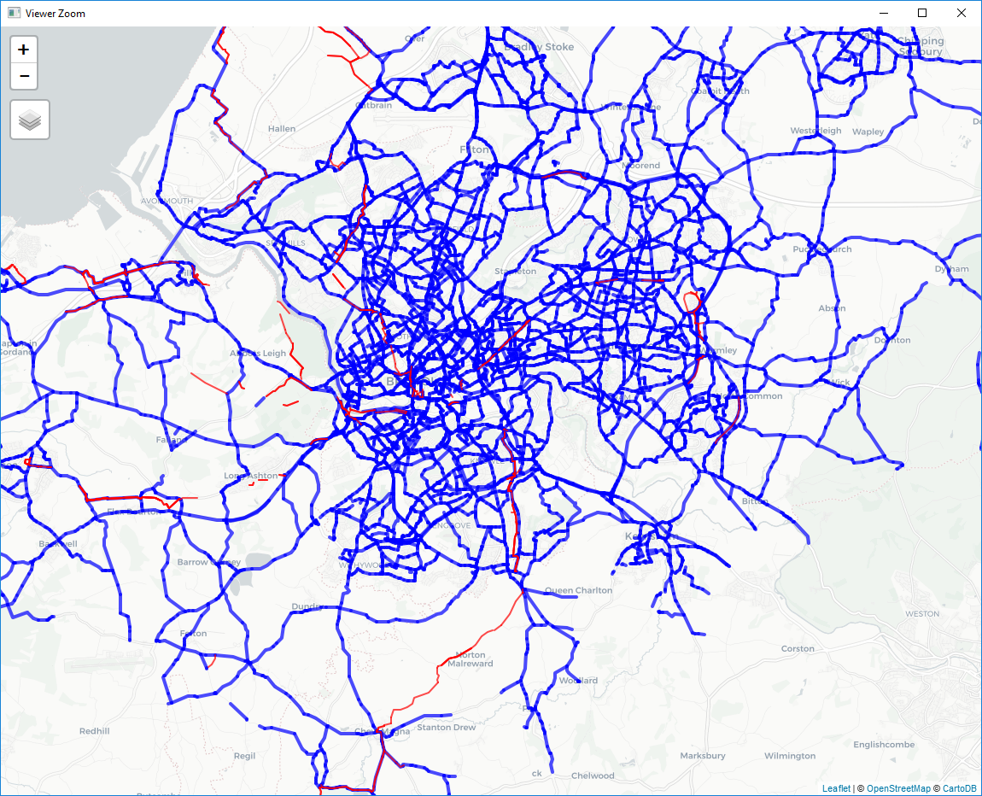

Bristol, blue osm network on MSOA routes, red infra change between 2001 and 2011